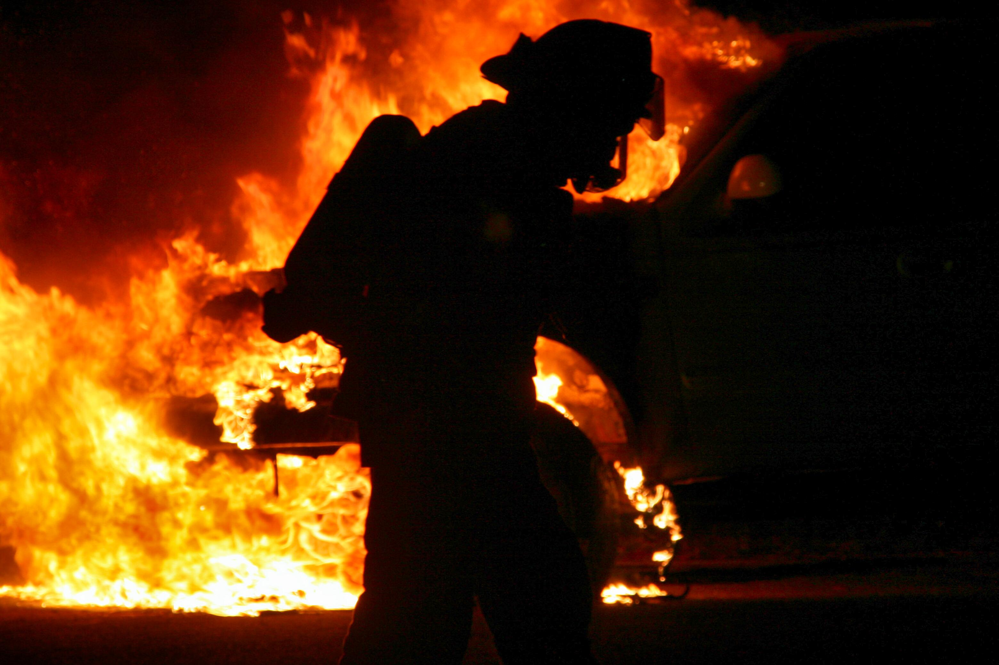
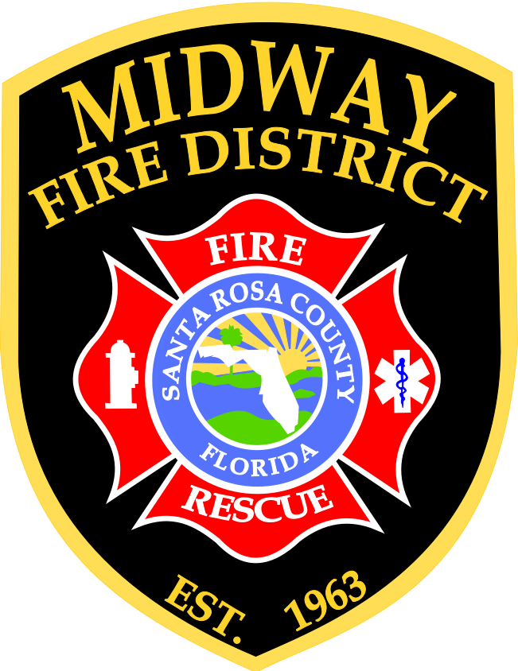

Goals & Objectives

Fiscal Year 2026
TABLE OF CONTENTS
TO our residents 3
Our Mission 3
Our Vision 3
Our Values 3
Our Purpose 3
Organizational units & functions 4
Organizational unit function – cont’d 5
Goal, Objectives, & performance metrics 6
Operations 6
Information Technology 7
Fire and Life Safety 8
Summary 8

TO our residents

Our Mission
To provide the highest quality emergency and non-emergency service for the preservation of life, property, and the environment, through professional development and dedication.

Our Vision
To grow with the needs of our community through the expansion of services, striving to provide excellence now and in the future.

Our Values
Professionalism, Integrity, and Compassion

Our Purpose
The purpose of this act is to promote the health, welfare, and safety of the citizens and residents of Santa Rosa County who reside within the geographical limits of that area known as the Midway Fire District, by providing for:
- Firefighting equipment.
- The establishment and maintenance of fire stations and fire substations.
- The acquisition and maintenance of all firefighting and protection equipment necessary for the prevention of fires or fighting of fires.
- The employment and training of such personnel as may be necessary to accomplish fire prevention and firefighting, the establishment and maintenance of emergency service.
- The acquisition and maintenance of rescue and other emergency equipment; and the employment and training of necessary emergency personnel.
The district may provide Advanced Life Support services within the district’s boundaries. The district shall have all other powers necessary to carry out the purposes of the district as otherwise provided by law, including, but not limited to, the power to adopt all necessary measures, rules, and regulations and policies relating to said purposes.
“Community Service is the foundation of everything we do!”

Organizational units & functions

Below is a list of units within the Midway Fire District organization, along with the functions they provide.

Administration: Provides administrative support to the Fire Chief and Command Staff; provides direction, oversight, and coordination for the annual budget process; manages the information technology systems; manages the payroll system; develops and monitors district and community surveys; performs liaison work with the Human Resources Branch; and prepares, reviews, and presents District staff reports to staff and District officials.
Human Resources: Provides district-wide direction and guidance to staff and district officials on local, state, and federal HR laws, rules, and regulations; develops appropriate HR systems for the employee’s on-boarding experiences through their organizational life cycle; designs, develops, and monitors the employee’s performance evaluations/appraisals; and monitors/evaluates the district health, wellness, and benefit programs.
Finance: Is responsible for all payroll, accounts payable/receivable, revenue and expenditure projections, annual budget development and associated budget amendments, and any special financial projects needed within the district.
Operations: Provides fire protection, ALS services, and High Angle Rescue "around the clock" to residents within the 32563 zip code, as well as providing mutual aid to the City of Gulf Breeze, Navarre, Navarre Beach, Pensacola Beach, and Avalon-Mulat areas. Midway Fire District staffs a total of 36 Operational personnel on three 48-hour shifts located at 2 fire stations.
Professional Development & Training: Provides a multitude of service delivery enhancements through high-caliber and progressive training, various educational delivery mediums, and professional development curriculum. This is accomplished through quality control mechanisms, strategic initiatives, staying abreast of local, state, and federal compliance rules, regulations, and administrative codes, and working with regional partners to achieve industry best practices.

Organizational unit function – cont’d

Information Technology: Provides specialized computer and network security operations within the district. I.T. is responsible for network and server administration, hardware and software compliance/installation, website maintenance and accompanying network responsibilities, server maintenance, licensing review and compliance, and assistance with technical matters.
Fire and Life Safety: Fire and Life Safety: Provides professional fire and life safety code knowledge and public education activities throughout the community to save lives and reduce property loss. This is achieved through the following activities: daily existing building/assembly and new construction inspections, business inspections, fire plan review and oversight, water/fire flow and fire hydrant testing, fire protection system(s) analysis, special community event inspections, attending local and state educational seminars/conferences, attending local planning, zoning, and site development meetings, and provide origin and cause investigations coupled with assisting the State Fire Marshal’s Office.
Emergency Management: Provides specialized disaster management guidance to include planning, preparedness, mitigation, response, and recovery activities. Serves as the liaison with regional emergency management partners and the Santa Rosa County emergency operations center (EOC).

Goal, OBJECTIVES, & performance metrics

Operations
- Goal: To deliver emergency services with a response time of eight minutes or less, 90% of the time.
  - Objective: Ensure resources are available to meet the goal. Ensure all emergency apparatus and equipment are in service and well-maintained. Ensure staffing is available to meet the goal by hiring and maintaining qualified, high-performing employees.
  - Measurement: Extract data from the incident reporting system, EPR. Evaluate response times monthly at the Board of Commissioners meetings.
- Goal: Fleet replacement Cycle Fire Engines
  - Objective: Replace front-line fire engines every ten years. Develop and maintain a financial planning mechanism to fund the replacement of fire engines.
  - Measurement: NFPA 1911, Standard for the Inspection, Maintenance, Testing, and Retirement of In-service Emergency Apparatus
- Goal: Fleet replacement Cycle Ladder Truck Apparatus
  - Objective: Replace front-line Ladder trucks every fifteen years. Develop and maintain a financial planning mechanism to fund the replacement ladder truck apparatus.
  - Measurement: NFPA 1911, Standard for the Inspection, Maintenance, Testing, and Retirement of In-service Emergency Apparatus
- Goal: Increase firefighter performance and safety on the fireground emergency scene by sending firefighters each year to the Fire Department Training Network for hands-on live fire training.
  - Objective: Develop fundamental critical skill sets that are required for structure fires.
  - Measurement: Extract data from the incident reporting system, measuring specific structure fire benchmarks of 1.) Water on the fire time 2.) Primary Search Completion time.

Goal, OBJECTIVES, & performance metrics – cont’d

Information Technology
- Goal: In conjunction with finance, incorporate online payment options for fees required by the district.
  - Objective: Eliminate onsite payments
  - Measurement: Evaluate monthly the amount of required fees that are being paid online versus onsite.
- Goal: Establish a single central network drive for all Midway Fire District documents that all authorized users can access.
  - Objective: Eliminate document compartmentalization on multiple hard drives.
  - Measurement: Evaluate the monthly progress of organizing the procurement of needed hardware to implement the change and/or the transfer of documents to the central network drive.
- Goal: Provide all personnel with Microsoft access.
  - Objective: Eliminate the need for personnel to use their personal electronic devices to create departmental reports.
    - Measurement: Evaluate monthly the progress of achieving Microsoft access for all personnel and/or Q&A monthly on the use of the software.

Goal, OBJECTIVES, & performance metrics – cont’d

Fire and Life Safety
- Goal: Establish an ordinance for the safe operation of food trucks/trailers.
  - Objective: Ensure all food trucks/trailers operating within the Midway Fire District are adhering to a standardized list of fire and life safety criteria.
  - Measurement: Initial occupancy inspections of all food trucks/trailers coupled with periodic fire and life safety inspections to accomplish 100% compliance.
- Goal: Create updated inspection and plan review policy and procedures
  - Objective: Ensure inspections and plan reviews are being conducted and documented in a standard fashion.
  - Measurement: Conduct periodic Q&A on completed inspections and plan reviews.
- Goal: Establish a re-inspection program.
  - Objective: Utilize on a part-time, overtime basis those members of operations who hold their Fire Inspector 1 certification.
  - Measurement: Evaluate monthly how many re-inspections are being completed compared to the previous year.
- Goal: Utilize more of the capabilities of our emergency reporting system (EPR) as it pertains to plan reviews.
  - Objective: Upload all electronic documents pertaining to a plan review into the EPR system.
  - Measurement: Evaluate on a per plan review basis that all electronic documents are being uploaded into the EPR based on our policy and procedures.
- Goal: Expand our fire and life safety community outreach efforts.
  - Objective: Increase the number of organizations that participate in fire and life safety education.
  - Measurement: Evaluate monthly the number of fire and life safety events being conducted against the same month of the previous year.

Summary
Midway Fire District strives to be the leader among special districts in all aspects of the fire service. Through our goals, objectives, and measurements, we lead the way in successfully providing our Mission, Vision, Values, and Purpose to the residents of the Midway Fire District.

